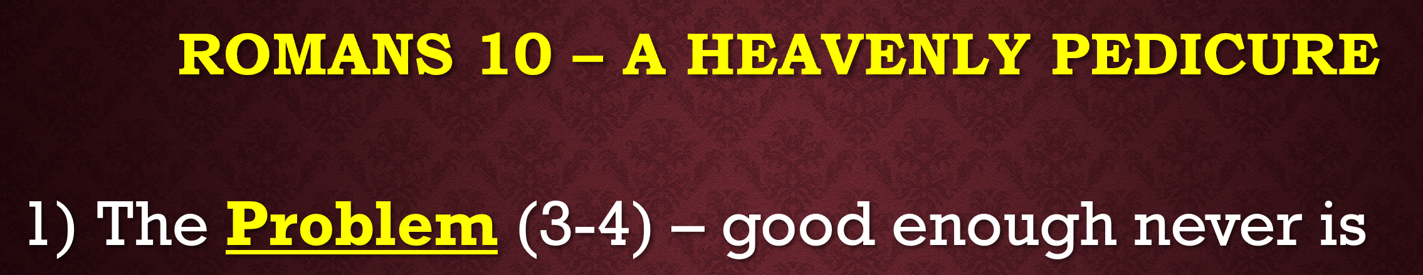

3- For not knowing about God's righteousness and seeking to establish their own, they did not subject themselves to the righteousness of God.

4- For Christ is the end of the law for righteousness to everyone who believes.

Chapters 9-11 are specific to the nation of Israel. And while they deal theologically with Israel they speak into our world. In chapters 9, 10, and 11 Paul deviates from his main argument and highlights the major change to Israel’s place in salvation history.
Israel, as God's elect, has rejected Christ as their Promised Messiah. Gentiles, on the other hand, were coming to Christ in droves.
They were still trying to pursue their own righteousness through the Law even though they could never attain it due to their sin. No one can!
The problem that was Israel’s is still a problem today. Mankind feels that they are good enough to get to heaven based on good deeds they have done.
(Ray Comfort and Kirk Cameron, Way of the Master)
- Disobeyed your parents?
- Lied?
- Stolen?
- Lustful thoughts?
- Filled with anger toward someone?
- God’s name in vain?
Based on your own admission you are a disobedient, lying, stealing, adulterous murderer who has used the name of the Lord in vain. You’ve already broken 6 of the 10 Commandments before a Just God who requires complete perfection.
Good enough, never is.
When Jesus Christ entered the scene, He came as the Promised Messiah, the Lamb of God who would take away the sins of the world, and the Lion of the Tribe of Judah.
Not only is He the Alpha and the Omega, the First and the Last, but He is Emmanuel, God with us. He is the Savior to the world, not just to Israel.
Jesus is
- THE ELECT,
- THE CHOSEN ONE OF GOD,
- THE ONE WHO WAS PREDESTINED BEFORE THE CREATION OF THE WORLD TO BE THE SAVIOR.
10:3 The Jews thought they were in no matter what because God had chosen them. But they missed the mark. They failed to realize that God still required of them a righteousness that they could never earn outside of absolute faith.
(i.e.) Abraham’s faith was counted unto him as righteousness. He believed in a future promise.
God had chosen Israel to make Himself known to the nations. Like Israel in the OT, you and I have been chosen by God to make Him known to the nations.
We are made to be the elect, the chosen ones, when we become saved and are then found to be IN CHRIST.
This is the best way I have come across to describe how you and I are God’s election.
UMBRELLA ILLUSTRATION
CHRIST is the elect. He is the Chosen One. When we are IN CHRIST, we fall under that label, under His umbrella of protection.
Romans 9-11 must be understood in its context; it is a text that is about Israel. There are spiritual truths that we take away from these chapters, but they must be read in context.
Context is King!
While Paul was thankful for their zeal; he knew that the problem was that their zeal for the Lord was misguided. They forgot the warning of Deuteronomy 9:4-5.
⁴ After the Lord your God has driven them out before you, do not say to yourself, “The Lord has brought me here to take possession of this land because of my righteousness.” No, it is on account of the wickedness of these nations that the Lord is going to drive them out before you. ⁵ It is not because of your righteousness or your integrity that you are going in to take possession of their land; but on account of the wickedness of these nations, the Lord your God will drive them out before you, to accomplish what he swore to your fathers, to Abraham, Isaac, and Jacob.
The problem is that they thought they were either,
- Automatically saved because they were God's chosen nation, the elect of God, or
- That they could be good enough based on their own righteousness. The sacrificial system, although ongoing, was good enough to make them right with Yahweh.
You and I know that the road to hell is paved with good intentions.
The masses that are on that path are either blinded to the truth because of their ongoing willingness to reject Christ, or perhaps because they were never told about Him.
Either way, Romans 1:18ff tells us that mankind is without excuse. NIV:
The wrath of this being revealed from heaven against all the godlessness and wickedness of men who suppressed the truth by their wickedness, since what may be known about God as plain to them, because God has made it plain to them. For since the creation of the world God's invisible qualities, His eternal power and divine nature, have been clearly seen, being understood from what has been made, so that men are without excuse.
The Five Solas of the Protestant Reformation are precise in doctrine and emphatic in displaying that salvation is 100% from God. The only thing man brings to the salvific equation is his sin and his need for a Savior.
Man is saved by grace alone, through faith alone, in Christ alone, according to Scripture alone, to the glory of God alone.
- Sola Gratia, Sola Fide, Solus Christus, Sola Scriptura, Soli Deo Gloria.
RCC is a modern-day comparison to who Israel was then.
Although these words were not penned by Martin Luther or John Calvin, they were later developed as a tidy summary of the Protestant birth, as Luther, then a Catholic priest, sought to challenge the errors in Roman Catholic doctrine.
In studying the Scriptures, Luther realized it was a man-made religion filled with travesties that placed the Roman Catholic Church over and above the teachings and truths of Scripture.
- A travesty is a false, absurd, distorted representation of something. In other words, the RCC leaders had exchanged the truth for a lie. Catholics do not believe in the Five Solas of the Protestant Reformation.
  - Grace alone – RC is a works-based religion. Penance is paid as a means to earn forgiveness -
  - Faith alone – prayer vigils to get someone out of Purgatory, praying to the saints.
  - Christ alone? You gotta get through Mary (Co-Redemptress; Hail Mary Full of Grace) to get to Jesus. She was the final Ark of the Covenant, having carried Jesus in her womb.
- Scripture alone – man-made rules… 7 Sacraments (baptism, confirmation, Eucharist, confession, anointing of the sick, holy orders, matrimony)
I share this because you and I know people who are Catholic. They are in our families. They are our friends. We care about them. But do we care enough about them to show them the truth?
- Are there Catholics who are saved? Absolutely.
- Is it difficult to have a conversation about religious beliefs with those whom we love?
  - I know first-hand that it can be extremely difficult.
But God is bigger, and there is a better way.
There IS a way to have a loving conversation with a Catholic (i.e.) that will allow you to share the truths of Scripture as compared to the ways of man.
I’ll offer that training sometime in the future.
But let’s get back to the Jews in Paul’s day. They were not ignorant of God's righteousness, but they were indifferent to His desire to make them righteous in and through Jesus Christ.
This all fits into the question of God’s Sovereignty vs. man’s free will. Today we would label it under the headlines of Calvinism vs. Arminianism.
(Calvinism) TULIP is based on an interpretation of John 6:44 –
- Total depravity (no man can come to me)
- Unconditional election (unless the Father)
- Irresistible grace (who sent Me draws him)
- Limited atonement (And I will raise him up)
- Perseverance of the Saints (on the last day)
(It is listed/spelled T-U-I-L-P to coordinate with John 6:44)
Only those whom God calls will be saved.
- If you are called you cannot say no, and
- if you are not called you could never say yes.
God is Sovereign, but man still has a free choice. Both are true. We just can’t wrap our finite minds around it.
The major point to make here ties into how one approaches the call to share our faith with a lost and dying world.
We are called to make disciples. Someone becomes a disciple of Christ by first being told about the Good News. We call this evangelism, but indeed, you and I are not called to evangelize, but to be witnesses. Matthew 28:20 – “And you will be My WITNESSES.”
Let’s get back to Romans 10. How did 1st century Judaism view this debate on God’s Sovereignty vs. Man’s Free Will?
There were 3 schools of thought:
- Pharisees - Their philosophy was that if you do good you will get good, and if you do bad you will get bad.

- Essenes believed in fate. Nothing happens outside of her decree. Man is but a pawn on God's chess board of His creation.

- Sadducees. They believed there was no such thing as fate. Our lives are under our own power. We are responsible for anything and everything that happens in our life and any misfortune is due to our own thoughtlessness or carelessness. A COMBINATION OF THESE THREE SETS OF BELIEF INFILTRATED THE EARLY CHURCH.
In 10:4 Paul is saying, if you think you are righteous, you are not.
Where v4 says that Christ is our righteousness, and He is the end of the law for righteousness to all who believe, the Greek word for end, τελος, can mean either a termination or to finally achieve a goal.
- Paul presents Christ as both the end of the law and the goal of the law. He also presents Christ as the fulfillment of the Law.
We can never be justified, made righteous with the court’s decision of not guilty, through obedience to the law. Why? Because on our own we ARE guilty of transgressing the Law.
- The Law is good because it points us to our need for Christ, much like how John the Baptist pointed humanity to Christ. He said, “I am not the one, but I point to the One who was promised. Repent, for the Kingdom of heaven is near.”
Galatians 3:24-25 says, “So the law was put in charge to lead us to Christ that we may be justified by faith. Now that faith has come, we are no longer under the supervision of the law.” Christ fulfilled the law.
- Matthew 5:17ff says, “Do not think that I have come to abolish the Law or the Prophets; I have not come to abolish them but to fulfill them. I tell you the truth, until heaven and earth disappear, not the smallest letter, not the least stroke of a pen, will by any means disappear from the law until everything is accomplished.”
- Romans 3:20, no one will be declared righteous in His sight by observing the law, rather, through the law we become conscious of sin.
- Romans 8:3-4, for what the law was powerless to do in that it was weakened by the sinful nature, God did by sending His own Son in the likeness of sinful man to be a sin offering. And so He condemned sin in sinful man, in the order that the righteous requirements of the law might be fully met in us, who do not live according to the sinful nature but according to the Spirit.
The PROBLEM is that righteousness is required to enter heaven, and there is no one righteous, no, not one. Mankind thinks it is good enough to get there, but you and I both know that JESUS CHRIST is the only way to heaven, and He is the One who makes us righteous when we are IN HIM (Umbrella). This is God’s PROVISION to all those who would confess and believe.

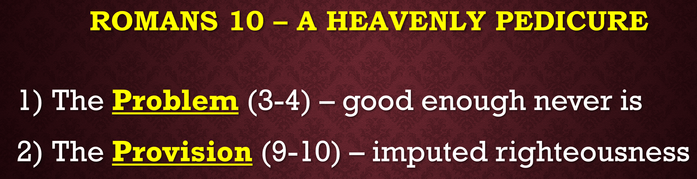

9 - That if you confess with your mouth Jesus as Lord, and believe in your heart that God raised him from the dead, you will be saved; 10 - for with the heart a person believes, resulting in righteousness, and with the mouth he confesses, resulting in salvation.

Vv. 9-10 create an ABBA formula. (mouth-heart-heart-mouth)
Jesus said in Matthew 12:34, “Out of the abundance of the heart the mouth speaks.”
It is an interesting discovery from the Greek text how the word confess both parallels and stands in subtle contrast with the word profess.
- To confess is to repent. To profess is to declare.
- Think of a pro (good) and con (bad) list. To profess Christ is good. To confess the bad things in our life, our sin, well, that is also good.
When it says if you confess with your mouth, Jesus is Lord, you were also confessing your sin. You are realizing his lordship over you.
- 1 Jn 1:9 says if you CONFESS your sins. This is the focus on admitting your wrongdoing.
- When you PROFESS something you are making a proclamation. In context to today’s message what you are professing, or proclaiming, is faith in Christ.
When we confess with our mouth, “Jesus is Lord,” we are pledging our absolute obedience and worship. Jesus has absolute authority in, through, and over our lives. LORD is the highest level of authority.
10:10
I have referenced my upbringing on a few occasions, but it once again applies well here.
As a former Catholic, I battle against the thought that I am declared not guilty and thus can stand before God as righteous.
It is difficult to grasp this concept for myself. But this concept is not a concept at all. It is truth, absolute and undeniable.
For something to be conceptual implies that it may not be true. Synonyms include theoretical, hypothetical, and speculative.
The truth that you or I can be declared righteous is truly unbelievable. So believe it!
It is this truth that Christians are called to share with those outside of the faith.
In 10:9-10, to confess and believe go hand in hand.
They involve a whole person commitment, which is illustrated by Paul using the mouth and the heart. You truly cannot have one without the other.
I would assert that outside of the Name of Christ without which no man can be saved, the SEVEN MOST POWERFUL WORDS in Scripture include:
- Repent
- Confess
- Faith
- Justified
- Righteous
- Saved
- Forgiveness
Why? Because they all center around Christ, and they are all for our benefit and for God’s glory.
And … they are all a part of evangelism. When we witness to someone what God has done for us, we are telling them that we
- were compelled to repent of our sins by confessing them,
- that we have put our faith in Christ for salvation,
- and as a result, we have been justified and made righteous before a holy God, and because of Christ we are forgiven.
BUT… There is a problem that is paramount today.
- People think they are good enough to get into heaven.
  - That is simply not the case.
- They feel they can earn it by doing good works.
  - Nothing could be further from the truth.
- Humanity says we do not have to be righteous because there is no god, there is no heaven/hell, there is no truth.
  - But eternity is too long to be wrong.
God has provided a remedy to man’s problem. This provision is an imputed righteousness. God also said that He desires to use you and me to declare these truths. God wants to use YOU to PRESENT these truths to a lost and dying world, to be a WITNESS to what He has done.

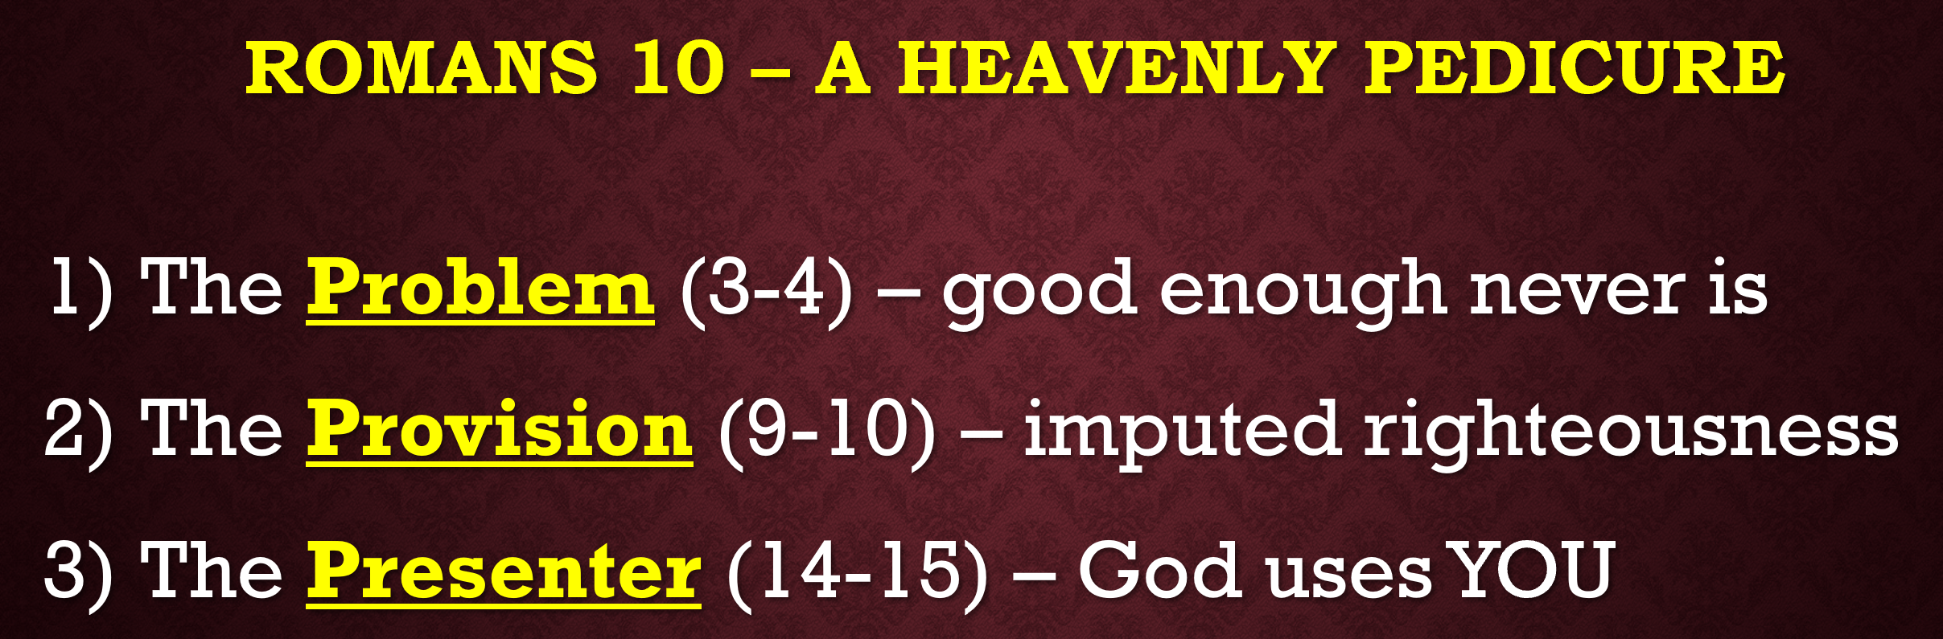

14 - How then will they call on him and whom they have not believed? How will they believe in him whom they have not heard? And how will they hear without a preacher? [witness]

15 - How will they preach unless they are sent? Just as it is written, “How beautiful are the feet of those who bring good news of good things!”

10:14 - is the climax to Paul's argument for Israel to no longer pursue a failed righteousness on their own, but to come to Jesus the Lord, for he is the one upon whom the Old Testament points.

God's plan for Israel was to have their salvific climax in Christ, who was their Promised Messiah.
The entire Old Testament pointed to the heightened and now universal truth that Jesus Christ is the Savior to all who would believe, first for the Jew and then for the Gentile.
The word, Heard, implies understanding the significance of that which is preached.
There can be no call, no hearing, no belief, unless someone communicates the truth to them.
The standard for all believers in preparation for the evangelistic event is to have a 30-second, a 3-minute, and a 30-minute presentation of the gospel message.
It is the proclamation of the good news for which we are all made to be vessels to share Christ. Salvation can only begin when we share.
10:15
How beautiful are the feet of him who brings good news. The title for today’s message is called, “A Heavenly Pedicure.”
- They had open sandals, dirty roads, and thus dirty, smelly, stinky feet. The lowest position among the slaves was the boy who would wash the feet of those who entered a house.
- To have a heavenly pedicure is to be cleansed by God and then to relate that offer for cleansing to others who have dirty, smelly, stinky feet.
- We are washed by the Word according to Ephesians 5:26.
I do not want to get bogged down trying to justify a sermon title by proof texting various scriptures.
The point of a Heavenly Pedicure is to illustrate a spiritual truth, that you and I need to undergo a process of preparation.
Sharing the good news should not be an intellectual battle, or an apologetic sparring contest concerning world religions or perceived truths.
It is a direct conversation whereas the sinner is introduced to the Savior. The good news comes at the heels of the bad news (our sin and separation from a holy God because of it).
10:15 as a slap in Israel's face. God has sent them this truth before in Isaiah 52:7, of which Paul is quoting here. They rejected it then, and they are rejecting it now.
What was the context for Isaiah 52:7?
It was an announcement of good news to the exiled people of Israel that they could now return to their homeland. Paul uses this as an example for the good news of Jesus Christ that God has intervened, and He is offering redemption in Christ. The born-again believer would then be journeying toward their new homeland, which is in heaven above.
The problem is sin and that good enough never is. Works cannot get you into heaven. Only a saving relationship with Jesus will. God has provided Jesus as a sacrifice for our sins, and He desires for you and for me to be witnesses to this wonderful truth.
We are the hands and the feet of Jesus, and the mouthpieces through which God will present this truth to the lost and dying world around us. We call this evangelism, but indeed, it is witnessing that we are called to do.
Religion won’t get you into heaven, either. I fear that there are tens of thousands who call Roman Catholicism their ticket into heaven, should they ever advance past Purgatory that is, but that the ways of man, of a false religion, will only set them on that vast and crowded road toward eternity in hell.
We can never earn forgiveness; we can only freely accept it. God also uses the truth of His Word to proclaim this message. The Heavenly Pedicure is not complete unless it is trimmed by God’s Word.
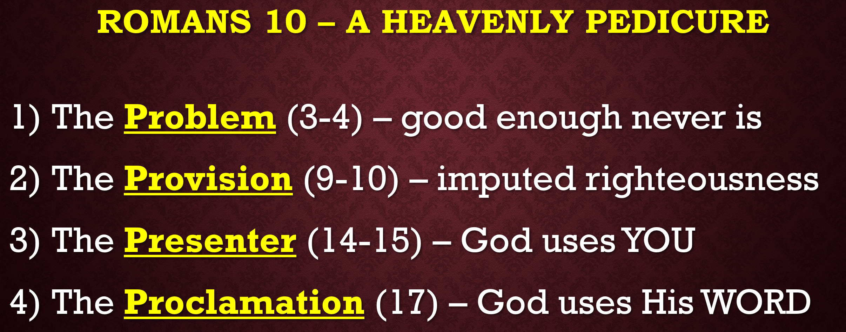

17 - So faith comes from hearing, and hearing by the Word of Christ.

10:17 is the climax to Paul’s argument that the Law could never be the vehicle upon which man would attain righteousness.
People need to hear the good news of salvation in Christ to believe in it. We extend the offer, but the results are up to God.
Although the verses contained in chapter 10, as a matter of fact chapters 9 through 11, are specific to Israel, their spiritual truths are universal and applicable to us today.
Evangelism is a noun that means the good news.
Witnessing is the activity that we are called to do.
If Jesus is your Lord, then there is no debate. Witnessing is mandatory.
Do you love Jesus? Do you truly love Him? In John 14:15 Jesus said, “If you love me, keep My commandments.”
I’m saying these things in love, and I am saying these things with fingers pointed at myself, too. There comes a time when soft love needs to become tough love. Churches across America need a wake-up call. Christians need a wake-up call. I need a wake-up call.
If you are not witnessing on an ongoing basis, or better stated, if being a witness for Christ is not happening verbally as an overwhelming and compassionate desire to see the lost saved, then something is wrong.
The diagnosis is that spiritual apathy and complacency are diseases in your life. The cure is to drink of the cup that is spiritual maturity. The result of spiritual maturity, according to Philippians 1:9-11, is to bring glory to God through the evangelistic event called witnessing.
And it is my job to equip you with the tools needed to be successful. The pressure is not on you, but on me. I just need your buy in. God is wanting your commitment to His process. It’s my job to give you the tools and the training to become a successful witness for the Lord, and it doesn’t happen overnight.

